**DAILY ONLINE ACTIVITIES SUMMARY**

|  |  |  |  |  |  |  |  |  |
| --- | --- | --- | --- | --- | --- | --- | --- | --- |
| **Date:** | 18-05-2020 | | | | | **Name:** | JYOTHI B R | |
| **Sem & Sec** | Vi A sec | | | | | **USN:** | 4AL18CS030 | |
| **Online Test Summary** | | | | | | | | |
| **Subject** | | COMPLEX ANALYSIS, PROBABILITY AND STATISTICAL METHODS | | | | | | |
| **Max. Marks** | | 30 | | **Score** | | | Not given | |
| **Certification Course Summary** | | | | | | | | |
| **Course** | Programming Essentials in Python | | | | | | | |
| **Certificate Provider** | | | Cisco Virtual Academy | | **Duration** | | | **2 hr** |
| **Coding Challenges** | | | | | | | | |
| **Problem Statement:** 1 Frequency of each letter in a string  2 Printing odd and even num using threads  3 to check the anagram | | | | | | | | |
| **Status:** completed | | | | | | | | |
| **Uploaded the report in Github** | | | | | yes | | | |
| **If yes Repository name** | | | | | https://github.com/JyothiShetty/lockdown-coding | | | |
| **Uploaded the report in slack** | | | | | yes | | | |

Online Test Details: (Attach the snapshot and briefly write the report for the same)

Certification Course Details: (Attach the snapshot and briefly write the report for the same)

Coding Challenges Details: (Attach the snapshot and briefly write the report for the same)

**Online Test Details**: The online test was from module 4 which was about curve fitting and statistical method. There were 30 questions and the duration were 30 minutes. The questions were optimal and were easy. The score for the test was not displayed after the test for some reason. Snapshot: not taken

**CERTIFICATION COURSE DETAILS:**

Programming Essentials in Python :

* the fundamentals of computer programming;
* setting up your programming environment;
* compilation vs. interpretation;
* introduction to Python.

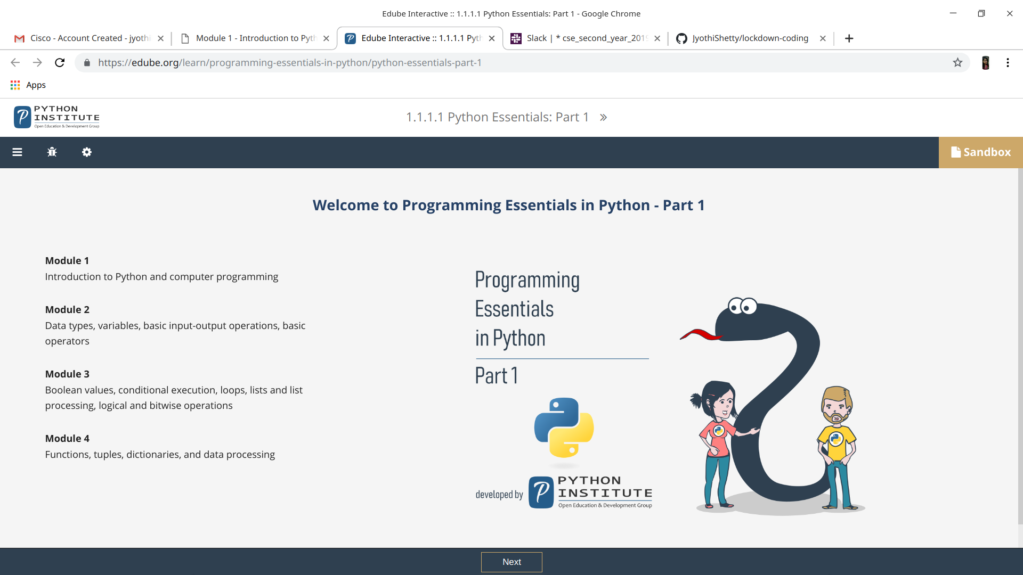

**Online coding:**

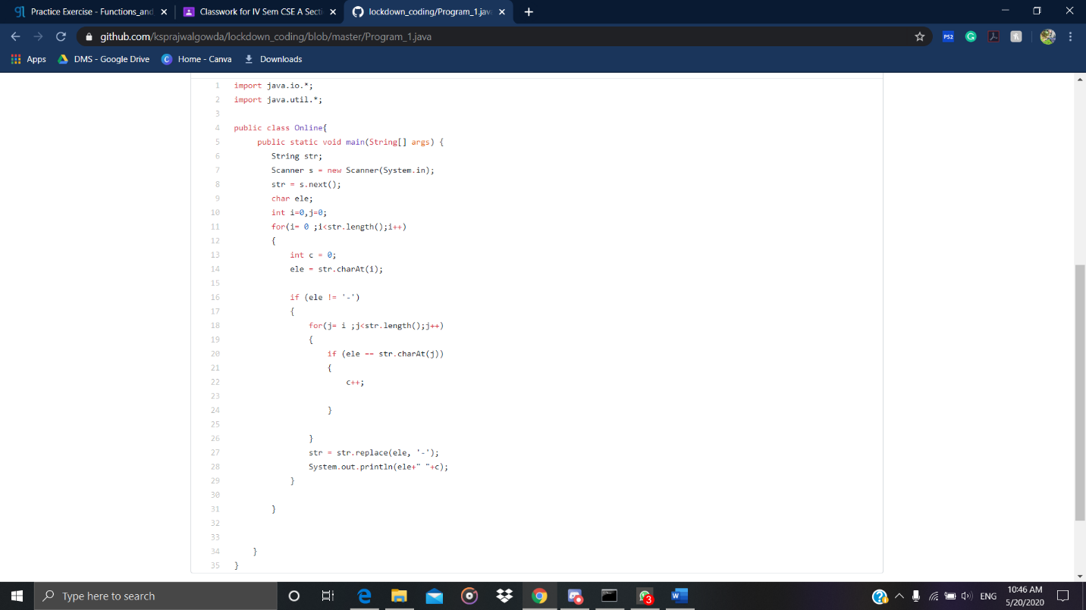 **Find the frequency of all the letters in a given string**.

**write down a java program to print even and odd numbers series respectively from two threads: t1 and t2 synchronizing on a shared object  
Let t1 print message “ping — >” and t2 print message “,—-pong”.**

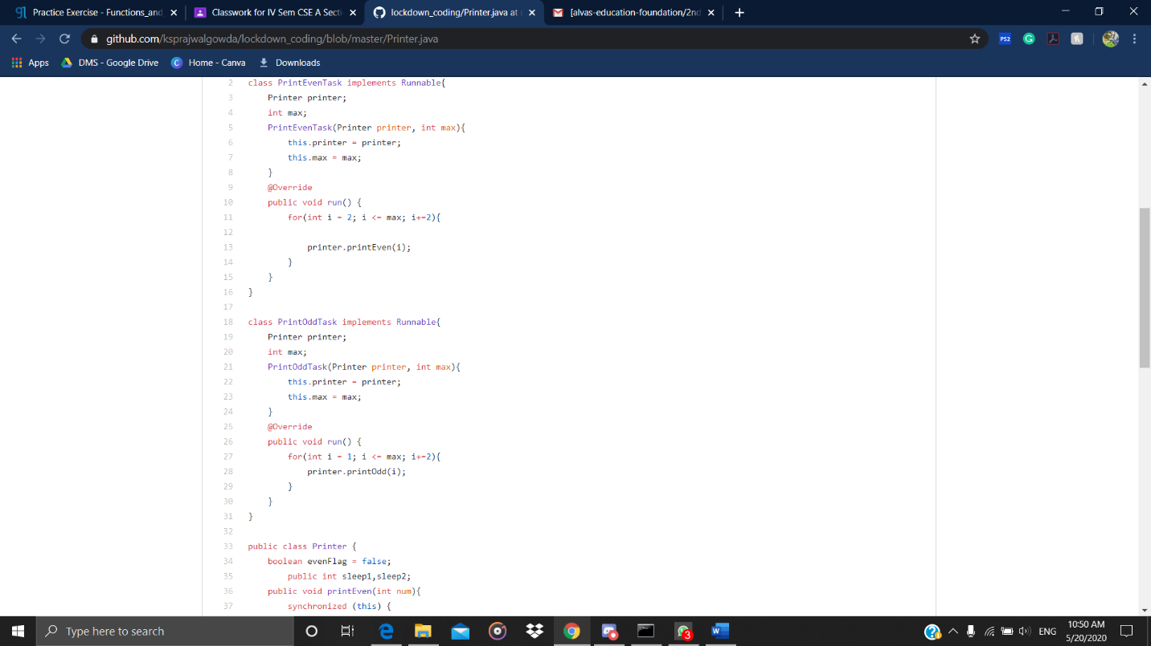

**Check whether the two given strings are anagram or not.**

